**Problem Statement :**

AtliQ Hardware is a company which supplies computer hardware and peripherals to many of their clients, they have these clients called Excel Stores, Normal Stores etc. across India and they supply all these equipment to them.

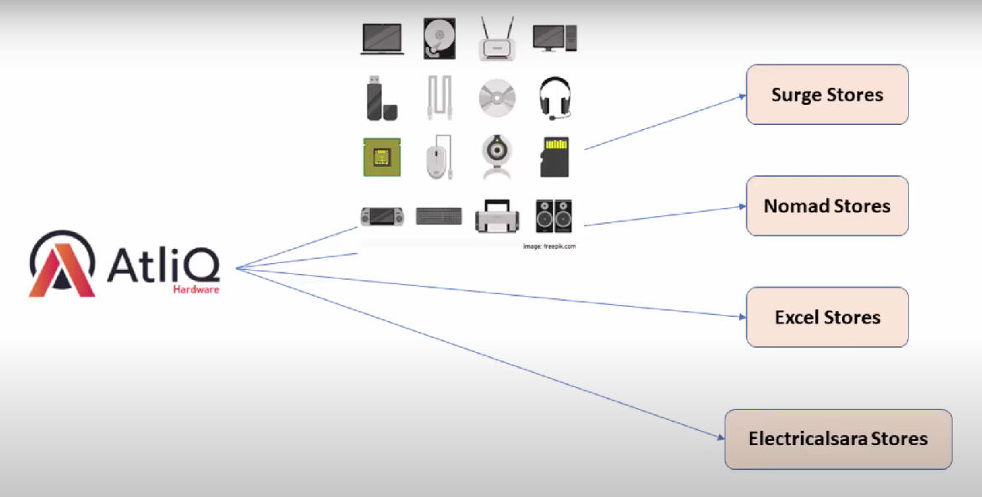

AtliQ Hardware has a head office in Delhi India and they have a lot of regional offices throughout the India. Now Bhavan Patel is the sales director for this company and he is facing a lot of challenges.

**Challenge :**

The market is growing dynamically and then he is facing issues in terms of tracking the sales in this dynamically growing market and he is having issues with the insights of his business so he has this regional managers for North India, South India and Central India, whenever he wants to get insights in these three regions, he would call these people and on the phone these local regional managers will give him some insights about the current quarterly sales and the upcoming quarterly targets and growths but the problem is the conversation which is happening that is all verbal and all the managers try to paint the rosy picture and they sugarcoat the facts. So Bhavan Patel the sales director is extremely frustrated with this because he sees that over all the sales are declining but when he is talking with his regional managers he is not getting the true picture, when he asks for the numbers, what these people will do is they give him a lot of excel files and AtliQ Hardware is a pretty big business and they have many clients so the excel files are pretty big and they won't tell him in the simple numbers that how the business is doing, what are the biggest areas where we need to focus so that if in any region the sales are declining then may be we can start some promotional offers or engage with the customers in a more better way so that we can increase our sales. So basically he is interested in getting a simple, understandable, digestible insights, so he is interested in a dashboard from where he can look into the real data. If the data is coming from a correct source and you build a visualization then for Bhavan it will become very easy to monitor the sales and their trends and he can also set monthly email reminders where at the end of the month Power BI will send him an email mentioning everything about the customers revenues etc. then he will not rely on the managers and he will be totally dependent on the data and then he can also take data driven decisions and these decisions will help him increase the sales for the company.